Age Guidelines For Limiting Resuscitation Thoracotomy Mortality

Student: Jacob L. Canfield

Advisors: Dr. Victoria Schlanser, Dr. Andrew Dennis, Dr. Julian Henderson

# Abstract

Resuscitative Thoracotomy (RT) is a potentially lifesaving intervention that is important in the setting of trauma to the thorax. Due to the high mortality rate of this procedure, guidelines are continuously evolving to provide a framework for practitioners to determine whether RT is warranted for a given case. Many of the guidelines currently in place involve factors such as mechanism of injury (MOI) i.e., blunt or penetrating, minutes of CPR performed before arrival at the emergency department (ED) and signs of life (SOL). The two major institutions creating these guidelines are the Eastern Association for the Surgery of Trauma (EAST) and the Western Trauma Association (WTA). Currently, neither of these institutions provides guidelines regarding the efficacy of RT based on age. RT is no longer a procedure performed liberally due to studies showing high mortality rates for trauma patients. There is an increased need to establish guidelines and algorithms to stratify patients into categories that minimize unnecessary harm and maximize the benefit of this procedure. Therefore, we aim to establish an age-based mortality threshold above which RT is contraindicated based on mortality statistics using the National Trauma Data Bank (NTDB).

# Specific aims

1) Obtain access to NTDB and isolate case data for patients who underwent RT. Process data and exploration of data for information about the demographics and circumstances of relevant cases (i.e., hemodynamic stability on arrival, vital signs, MOI, duration of CPR prior to arrival of ED, and SOL present).

2) Explore data for age relationships with mortality. Additionally, determine if there are secondary contributing factors that further stratify mortality within given age ranges. Secondary factors can be corroborated with current algorithms and criteria proposed by EAST and WTA.

3) Establish statistically driven threshold for mortality guideline beyond which RT is contraindicated. Further stratify with secondary factors if relevant relationships are established.

4) Evaluate efficacy of threshold by calculating an area under receiver operator curve (AUROC) score. Further evaluation can be achieved by calculating the mortality of patients above the age threshold and perform a test of significance to compare with the mortality across all age ranges.

# Significance & Background

RT is a damage control surgery performed to locate and control exsanguinating bleeding in the thorax. Additionally, access to the heart to correct cardiac tamponade and to explore the diaphragm with the goal of identifying diaphragmatic injury (DI) can be accomplished (Mitchell et. al). The patient has antiseptic skin preparation applied and is draped. A left mammary anterolateral thoracotomy is made from the sternal margin to the axillary fossa. From this point, the incision can be extended to a bilateral thoracotomy, also called a clam-shell thoracotomy, which can be performed when access to the right side of the thorax or mediastinal structures must be addressed. RT is performed with the objective of controlling exsanguinating bleeding from the heart, lungs, or major vessels, decompression of pericardial tamponade, preventing blood loss infradiaphragmatically, cross-clamping the descending thoracic aorta, or initiating internal cardiac massage (site paper this was from here).

MOI plays a significant role in the mortality of RT performed in the civilian sector. As described by Mitchell et al., civilian literature indicates a survival rate of 1-2% for blunt traumas and 11-16% for penetrating trauma. Major governing associations have established numerous guidelines and algorithms, namely the Western Trauma Association (WTA) and the East Association of the Surgery of Trauma (EAST). According to the algorithm devised by the WTA, the primary indicators for performing RT are patients presenting with signs of life present but in refractory shock (defined as arriving while undergoing CPR with SOL or systolic blood pressure (SBP) <60 mmHg). Alternatively, patients presenting without SOL and undergoing CPR for less than 10 or 15 minutes for blunt or penetrating trauma (penetrating trauma to neck or extremities with >5 minutes of CPR leads to non-salvageability), respectively, are indicated for RT.

In this work, we propose introducing additional guidelines related to the patient's age. To our knowledge, the literature does not include studies that evaluate the relationship between RT mortality and age. Although there are works that describe thoracotomy mortality rates performed for non-emergent cases (cite paper here), there has yet to be a study exploring this topic in emergent traumatic scenarios. We hypothesize that the mortality of RT increases with age and that there is an age-threshold that can be identified over which RT is no longer recommended as a therapeutic modality.

In older patients, hemodynamic instability secondary to trauma, lengthy CPR, and invasive procedures such as RT are not tolerated as well as in younger patients (Does age matter? The relationship between age and mortality in penetrating trauma). It is important to recognize that there is less data on penetrating trauma in the elderly where the main MOI in this age population tends to be blunt. Also, it is noteworthy that most trauma cases are of blunt origin and generally have a higher survival rate than penetrating traumas (cite that paper again). This publication also showed mortality rates of both blunt and penetrating traumas remained steady until age 55 (cite here). At first glance this seems contradictory to the previous statements and works regarding RT mortality which state that blunt trauma has a substantially lower survival rate in comparison to penetrating traumas of the thorax. This speaks to the complexity of the anatomy and importance of MOI when dealing with thoracic trauma compared to the above study which did not differentiate between anatomical compartments of trauma.

In patients above the determined age threshold, RT would be a low-yield, high-cost procedure that may ultimately cause additional and avoidable harm. By establishing a robust age-specific threshold, unnecessary RT can be avoided in lieu of rapidly pursuing alternative interventions that yield better outcomes for the patient.

# Design & Methods

The NTDB will be used to obtain mass data from trauma cases across the country to perform mortality analysis and stratification by age and secondary factors (Table 1., Figure 1.). Cases to be used for our study will be isolated by filtering for cases in which a resuscitative thoracotomy was performed and that have a valid value in the age data field. Subsequently, overall mortality rates for RT will be performed and additionally, for RT performed with MOI of penetrating and blunt trauma separately due to their reported discrepancy in mortality as reported and established in civilian literature.

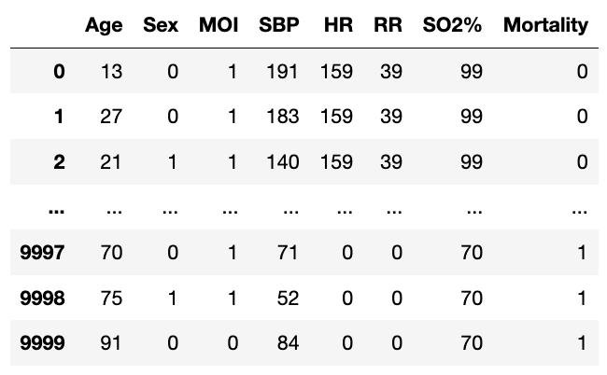

**Table 1. Example data obtainable from NTDB.** NTDB has an online data dictionary that can be referenced for determining potentially available data features available for each case along with their codifications. This table is mock data generated using packages from Python 3.

Next, overall mortality and MOI will be determined by age placed into 10-year bins (i.e., ages 51-60 etc., see Figure 2.). Statistical analysis will be performed to compare these age-specific mortality rates to overall mortality rates. Several methods for establishing the age cut-off for which RT will be contraindicated will be explored. Proposed methods of establishing this threshold include but are not limited to choosing a mortality rate manually (least useful), determining what age group begins to show statistically significant deviation from general mortality rates, determining rates of change in mortality across age groups, or performing a regression analysis that minimizes mortality below threshold while simultaneously minimizing denying candidates for RT that would benefit from the procedure above that age range.

There are numerous statistical methods that can be used to determine a statistical threshold. A manual threshold can be set by determining a mortality rate for which the value is deemed too high (for example, stating that a mortality rate exceeding 70% is unacceptable). This method does not utilize any information about the dataset and is left to the designer of the study to set it and as a result is not a very robust method. AUROC score could be used to test numerous thresholds and then the threshold that maximizes this score can be selected. This is a valuable method as it incorporates the rates of true and false positives to establish the ideal threshold. Lastly, a very straightforward and statistically driven method is using the mean + 2SD which is equivalent to the 97.5 percentile (Figure 3.). This method is practical; however, it can only ever deem 2.5% of patients as contraindicated for the procedure. This method would therefore handle mortality rates at the upper extreme of the distribution, however, relatively high mortality rates may still lie below this threshold.

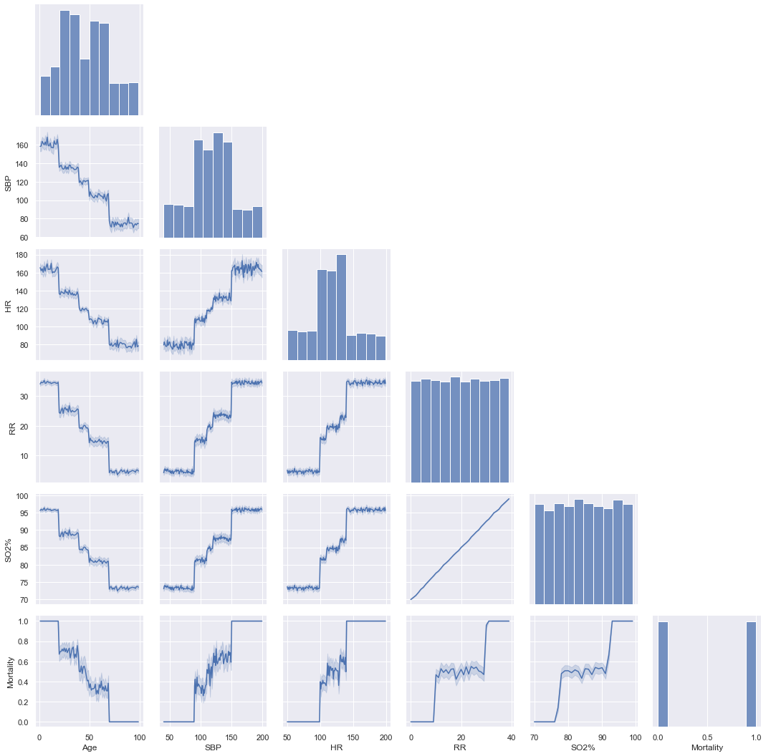

**Figure 1. Example data exploration of NTDB.** Mock data was generated using Python 3 packages as stated above. Diagonal shows a histogram of potential secondary factors to explore in the data set. Below the diagonal, plots show the relationships between two data features (for example Age vs. SBP). Deceased = 1 and survived = 0 for mortality.

To evaluate this method, the mortality of patients below age threshold will be statistically compared to mortality rates of overall population of cases that underwent RT. Additionally, the mortality above the age threshold will be calculated and statistically compared to population that underwent RT. With the given hypothesis that mortality of RT increases with age and that our established age threshold is valid, we would expect to see an improvement in mortality from RT in cases where the patient is in an age group below the threshold as well as a statistical increase in mortality in the age groups above our proposed age threshold.

In future works, further relationships between additional factors such as vital signs and MOI could be incorporated into a logistic regression machine learning model. This could be used to further validate the currently in place guidelines proposed by the EAST and WTA, in addition to discovering new relationships that may guide the creation of new guidelines and criteria. Full implementation of this could eventually be used to guide physician decision making in the field when given adequate patient information. Work of this caliber would be beyond the scope of this project but could be a plausible direction to pursue as the availability of big data algorithms improves and curated databases such as the NTDB continue to increase in size and quality.

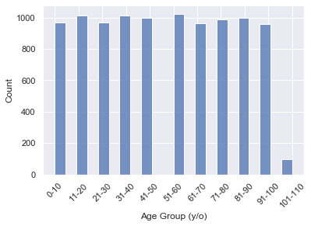

**Figure 2. Example of number of cases in each age bin.** Bins were made using 10-year intervals. Simulated data generated using Python 3 packages.

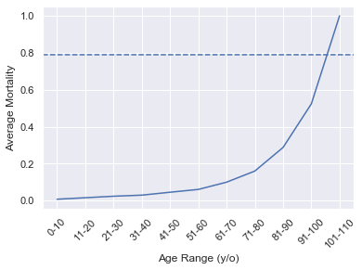

**Figure 3. Age ranges vs. Average Mortality with a threshold of mean mortality + 2SD.** Simulated figure data and threshold generated and calculated using Python 3 packages.

# References

1. Boddaert, G., et al. “Resuscitation Thoracotomy.” *Journal of Visceral Surgery*, vol. 154, Dec. 2017, pp. S35–S41, <https://doi.org/10.1016/j.jviscsurg.2017.07.003>. Accessed 14 Mar. 2024.
2. Breyer, M.D., Robert H. “Thoracotomy in Patients over Age Seventy Years.” *Journal of Thoracic and Cardiovascular Surgery*, vol. 81, no. 2, Feb. 1981, pp. 187–193, www.sciencedirect.com/science/article/pii/S0022522319376251. Accessed 14 Mar. 2024.
3. Cannon, Jeremy W., et al. “Damage Control Resuscitation in Patients with Severe Traumatic Hemorrhage.” *Journal of Trauma and Acute Care Surgery*, vol. 82, no. 3, Mar. 2017, pp. 605–617, <https://doi.org/10.1097/ta.0000000000001333>. Accessed 14 Mar. 2024.
4. Habibzadeh, Farrokh, et al. “On Determining the Most Appropriate Test Cut-off Value: The Case of Tests with Continuous Results.” *Biochemia Medica*, vol. 26, no. 3, 2016, pp. 297–307, <https://doi.org/10.11613/bm.2016.034>.
5. Harwell, Paige A., et al. “Outcomes of Rural Trauma Patients Who Undergo Damage Control Laparotomy.” *The American Journal of Surgery*, vol. 218, no. 3, Sept. 2019, pp. 490–495, <https://doi.org/10.1016/j.amjsurg.2019.01.005>. Accessed 14 Mar. 2024.
6. Hashmi, Zain G., et al. “Practical Guide to Surgical Data Sets: National Trauma Data Bank (NTDB).” *JAMA Surgery*, vol. 153, no. 9, 1 Sept. 2018, p. 852, <https://doi.org/10.1001/jamasurg.2018.0483>. Accessed 14 Mar. 2024.
7. Mitchell, Thomas A., et al. “An 8-Year Review of Operation Enduring Freedom and Operation Iraqi Freedom Resuscitative Thoracotomies.” *Military Medicine*, vol. 180, no. 3S, Mar. 2015, pp. 33–36, <https://doi.org/10.7205/milmed-d-14-00440>. Accessed 14 Mar. 2024.
8. Ottochian, Marcus, et al. “Does Age Matter? The Relationship between Age and Mortality in Penetrating Trauma.” *Injury*, vol. 40, no. 4, Apr. 2009, pp. 354–357, <https://doi.org/10.1016/j.injury.2008.10.015>. Accessed 28 Mar. 2024.
9. Radulovic, Nada, et al. “Predictors of Survival in Trauma Patients Requiring Resuscitative Thoracotomy: A Scoping Review.” *Trauma*, 15 Mar. 2023, p. 146040862311562, <https://doi.org/10.1177/14604086231156265>. Accessed 14 Mar. 2024.
10. Sharma, Megha, et al. “Chlamydia Trachomatis Associated Reactive Arthritis: A Urinary PCR Based Study.” *Indian Journal of Rheumatology*, vol. 9, Nov. 2014, pp. S48–S49, <https://doi.org/10.1016/j.injr.2014.10.145>. Accessed 5 May 2019.